PIPPA COMMENTS
Monthly Operational Report (Hydro)

ITEM | Comment
PLANT OPERATIONAL DATA
1.0 Rated / Installed / Nameplate Capacity, MW | Should “Rated”, “Installed” and “Nameplate” be treated separately? Or do they mean the same thing?
2.0 Commisison Month / Year | Please clarify if this is the start or end of the commissioning period. If this is necessary, we suggest to change it to “start of commercial operation”.
12.0 Water Utilization Rate, Cubic Meter/kWh | Suggest to change to "Average Water Utilization Rate"
12.0 Spilled Energy, MWh | Suggest to change to "Estimated Spilled Energy"
13.0 Spilled Energy, Million Cubic Meter | Suggest to change to "Estimated Water"
14.0 Reservoir Level and Stored Energy
14.1 Beginning
Equivalent (MWh) | Suggest to change to "Estimated Equivalent Energy"
14.1 Ending
Equivalent (MWh) | Suggest to change to "Estimated Equivalent Energy"
16.0 Inflow, MWh | Suggest to change to "Estimated Equivalent Energy of Inflow"
17.0 Outflow, Million Cubic Meter | This information is not necessary and might not be accurately measured since it could include evaporation, seepages and water consumption of other hydro plants using water from the same reservoir. Water Consumed (10) and Spilled Water (13) should be enough.
20.0 Plant Production Cost, Pesos/kWh | Should be deleted since Plant Production Cost is irrelevant for a hydro plant wherein fuel has no cost but limited and intermittent. Hydro plant operation is not cost-based but based on its optimum benefit to the system through water value. Additionally, these data do not have anything to do with the Rules and Procedures to Govern the Monitoring of Reliability Performance of Generating Units and Transmission System or its purpose(s) --monitor and determine reliability/availability of Generation Units and to make GenCos accountable.
21.0 Total Plant Operating Expenses, Php | This item is not relevant to the Rules and Procedures to Govern the Monitoring of Reliability Performance of Generating Units and Transmission System or its purpose(s) -monitor and determine reliability/availability of Generation Units and to make GenCos accountable.
GENERATION AND SALES DATA  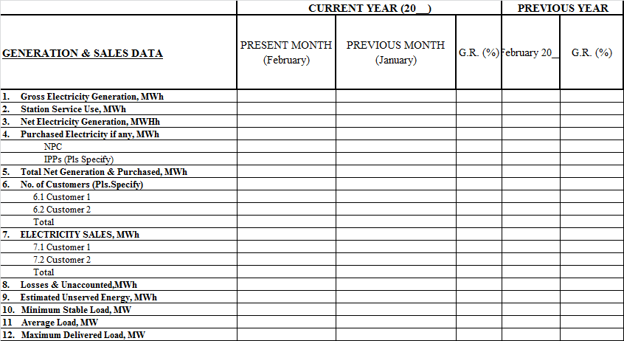 | The following item should be deleted since it is already available in the PLANT OPERATIONS DATA;  - Gross Generation  - Station use  - Net generation  - Minimum load  - Average load  - Maximum delivered load  Additionally, the following are not applicable in the current market set-up;  - Losses and unaccounted  - Estimated unserved energy  For the other Generation & Sales Data, these are required by the ERC Regulations (COC Terms and Conditions) but only on an annual basis after each fiscal period BUT not on monthly basis. Moreover, these data has no connection in monitoring reliability performance of generating units.

PIPPA COMMENTS
Monthly Operational Report (Geothermal)

ITEM | Comment
PLANT OPERATIONAL DATA
5.0 Total Station Used, kWh | Kindly change to “Total Station Use”
13. 0 Steam Deficiency, MWh | Kindly clarify the meaning of the term.
14.0 Plant Production Cost, Pesos/kWh | These items are not relevant to the Rules and Procedures to Govern the Monitoring of Reliability Performance of Generating Units and Transmission System or its purpose(s) -monitor and determine reliability/availability of Generation Units and to make GenCos accountable.
15.0 Total Plant Operating Expenses, PhP

PIPPA COMMENTS
Monthly Operational Report (Thermal)

ITEM | Comment
PLANT OPERATIONAL DATA
10.0 Total Fuel Expenses, Pesos | This item is not relevant to the Rules and Procedures to Govern the Monitoring of Reliability Performance of Generating Units and Transmission System or its purpose(s) -monitor and determine reliability/availability of Generation Units and to make GenCos accountable.

PIPPA COMMENTS
Monthly Operational Report (Wind)

ITEM | Comment
PLANT OPERATIONAL DATA
11.0 Plant Operating Cost, PhP/kWh | These items are not relevant to the Rules and Procedures to Govern the Monitoring of Reliability Performance of Generating Units and Transmission System or its purpose(s) -monitor and determine reliability/availability of Generation Units and to make GenCos accountable.
12.0 Plant Maintenance Cost, PhP/kWh
13.0 Total O&M Cost, PhP/kWh

PIPPA COMMENTS
Monthly Operational Report (Solar)

ITEM | Comment
PLANT OPERATIONAL DATA
12.0 Plant Operating Cost, PhP/kWh | These items are not relevant to the Rules and Procedures to Govern the Monitoring of Reliability Performance of Generating Units and Transmission System or its purpose(s) -monitor and determine reliability/availability of Generation Units and to make GenCos accountable
13.0 Plant Maintenance Cost, PhP/kWh
14.0 Total O&M Cost, PhP/kWh

